There is tons of information on the internet about how to build websites and there are many website templates to make building them easier. However, building websites is a creative process and should be treated as such. Not all websites have the same content or user base and, therefore, each website should be crafted to fit a company’s content and its users’ specific needs. Templates could be a good starting point, but websites ought to be unique. Discussed below are some best practices for content layout, menu structure, and design while crafting a one-of-a-kind website.

**The Standard Website Layout**

According to Locke (January 22, 2010), the standard website layout should contain a header that includes a logo and navigation buttons. A billboard, with new products or announcements, should be placed below the header. Below the billboard there should be some content, which could be divided up into several content areas (there are 3 content areas in the figure below). At the bottom of the website, should be the footer.

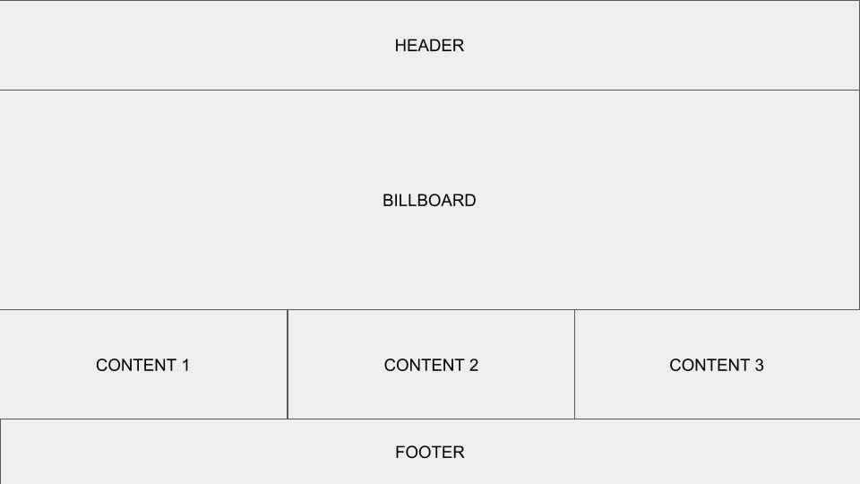Locke (January 22, 2010)

Locke suggests that this standard website layout can work for any company website.

While it is true that the standard website may be useful in many cases. There is more than one way to present information on a website. In fact, just a quick google search on website design layout will produce many results that are vastly different from the standard website layout. An article by Johnson (February 16, 2011), for example, discusses 10 different layouts for websites, which all look terrific and might be more suitable depending on the specific content of a website. For instance, he discusses the “Featured Graphic” layout (template below), which is useful if there is not much content and you want to showcase a single graphic image.

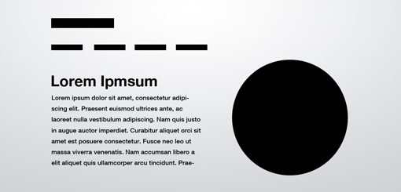Johnson (February 16, 2011)

So the best practice for website layout may just be to find the best layout for the content.

**Menu Structure for Good SEO**

A more important, but often ignored, consideration for websites is the site structure. Some websites have a better chance of ranking higher with search engines than others. Good search engine optimization (SEO), which affects how much traffic your site will get from searches, can usually be achieved by having a strong hierarchical menu structure (Patel, 2018). With strong structure, not only will you have better SEO, but the user experience will be better as well because users like to find things where they’re expected on websites. The more time the user spends on your website, the higher the website’s rankings. Additionally, web crawlers will have an easier time indexing pages from websites with a strong structure (Patel, 2018). Here are some tips (adapted from Patel, 2018) for a strong structure:

* Create a header with your main navigation pages
* Keep the number of main categories no more than seven
* Make sure that the navigation structure is not too deep
* Use internal linking structure to navigate between pages
* DON’T use dropdown menus or image-based navigational structure because crawlers have a hard time with that

**Website Design (aka Making It Pretty)**

Ultimately, a good website should be visually appealing. Yes, you can have a simple website just like the first CERN website shown here: <http://info.cern.ch/hypertext/WWW/TheProject.html>. However, users today prefer websites with a bit more pizazz. Here are some ideas worth considering when you develop a website gleaned from years of browsing through sites and having my own pet peaves:

* “Less is more” - Limit the content on the web page so it isn’t busy looking.
* Keep some “white space” - do not clutter up the website with too much content.
* Color scheme - choose a few coordinating colors - it’s not a clown outfit.

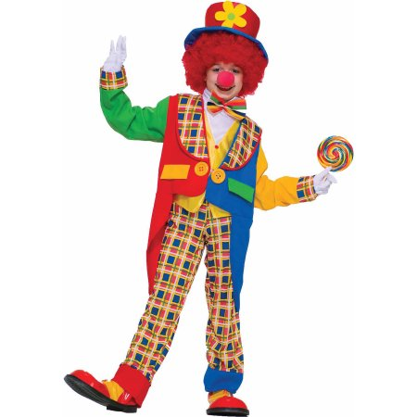([www.walmart.com](http://www.walmart.com))

**Summary**

Unique, attractive, and functional websites can be created when close consideration is given to layout, structure and design. That said, web development is a creative process, so have fun with it.

**References**

“Clown On The Town Child Halloween Costume” Retrieved from <https://www.walmart.com/ip/Clown-On-The-Town-Child-Halloween-Costume/32698269>

Johnson, J. (February 16, 2011). 10 Rock Solid Website Layout Examples. Retrieved from <https://designshack.net/articles/layouts/10-rock-solid-website-layout-examples/>

Locke, M. (January 22, 2010). Website Design Tips: The Standard Website Layout. Retrieved from <https://www.youtube.com/watch?v=3meSOXY9uGA>

Patel, N. (2018). How to Create a Site Structure That Will Enhance SEO. Retrieved from <https://neilpatel.com/blog/site-structure-enhance-seo/>

“World Wide Web” (1989). Retrieved from <http://info.cern.ch/hypertext/WWW/TheProject.html>